The project is supported by:
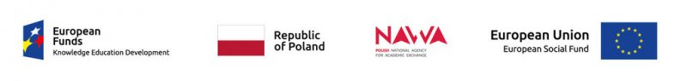Scientific Activity Support Office (COBN) informs about the extension of recruitment for 5-days visits for participation in research consultation with experts from the Wrocław University of Economics (seminars, workshops) (2 vacancies for Ph.D. Students).
The deadline for the application is 15th of April 2019.
Detailed information about the recruitment process can be found below.
cobn@ue.wroc.pl

