Attachment No 3 – Model of the agreement between the Beneficiary and the Project Participant

AGREEMENT
between
Name and address of the higher education institu-
tion: ............................................................................................................................................................................. hereinaf-
ter referred to as the “HEI”, represented by Mrs/Mr [name, surname, posi-
tion]: ............................................., being the Beneficiary in the Agreement for the implementation and
financing of the project under the PROM Programme – International scholarship exchange of doc-
toral students and academic staff (hereinafter the Programme), concluded with the Polish Na-
tional Agency for Academic Exchange, hereinafter referred to as the “Agreement with the HEI”. and
Mrs/Mr: [name, surname and PESEL number if available, address of the doctoral student or academic]: ...................................................................................................................................
hereinafter referred to as the “Project Participant”
The parties have agreed to the following terms of the Agreement

PROVISIONS OF THE AGREEMENT:

§1 – SUBJECT-MATTER OF THE AGREEMENT

- The parties have jointly agreed to effect a scholarship exchange under the Programme in compliance with the provisions of the Agreement with the HEI. The Programme is co-financed by the European Social Fund under the Knowledge Education Development Operational Programme.
- The Project Participant shall represent and confirm that they have read the Programme documentation and the obligations imposed on them in the Agreement with the HEI and the documents referenced therein and accepts them.
- The HEI will provide the Project Participant with co-financing for implementing a short form of education, (..... please provide a brief description of the action together with the period in which
it will be implemented), hereinafter referred to as the “Action”.
- The Project Participant shall accept co-financing and undertake to implement the Action referred to in paragraph 3.
- The Project Participant declares that they have read and accept the terms of this Agreement. Any amendments to this Agreement must be made in writing under the penalty of becoming null and void.

§2 – DURATION OF THE AGREEMENT

- The Agreement shall enter into force on the date of its conclusion, i.e. after signing by last of the parties.
- The Action will commence on .................. and last until ........................

§3 – CO-FINANCING FOR THE ACTION

- Co-financing of the costs associated with the Action shall amount to PLN ............, say
............................... The above amount consists of the amount for travelling of PLN ..................... and the amount for the living allowance of PLN .............. and .................. (please provide any other costs of the Action).
- The Project Participant undertakes to complete an evaluation survey constituting Attachment 2 to this Agreement, within the time-limit and on the terms set out in the Programme.
- The Project Participant is obliged to provide, depending on the nature of the Action, a suitable certificate proving the proper implementation of the Action – the model of such certificate constitutes Attachment No 3 to this Agreement.
- Within the period of ....... days from the completion of the Action, the Project Participant shall provide the HEI with a properly completed visit settlement form in accordance with the model constituting Attachment No 1 to the Agreement.

§4 – PAYMENTS TO THE PROJECT PARTICIPANT

- Within ..... days following this Agreement’s entry into force payment amounting to PLN ………. shall be transferred to the Project Participant.
- As to the remainder, the HEI shall transfer the funds to the Project Participant by ....................... once the visit settlement, referred to in § 3 paragraph 4is approved by the HEI.
- If the amount of funds provided to the Project Participant pursuant to § 4 paragraph 1 exceeds the amount payable indicated in the visit settlement, the Project Participant is obliged to return difference between the amount paid and the amount payable, within .... days following the HEI’s approval of the visit settlement. The funds returned by the Project Participant, referred to in the previous sentence, are the unused funds under the Agreement with the HEI.
- Payments shall be made ..... (indicate the method of making payments to the participant)........

§5 – PERSONAL DATA

The Project Participants, in concluding this Agreement, is obliged to submit a declaration of personal data, which constitutes Attachment 4 to this Agreement. Failure to submit the aforementioned declaration by the Project Participant shall constitute the basis for not paying of funds to the Project Participant and for the HEI’s withdrawal from this Agreement within 3 months from its conclusion, i.e. by ....................

§6 – APPLICABLE LAW AND JURISDICTION

Granting and payment of co-financing under the Programme shall be made in observance of the provisions of this Agreement, while considering the provisions of the Agreement with the HEI. Any disputed matters relating to this Agreement shall be settled in accordance with Polish legislation.

§7 – FINAL CONDITIONS

- The court with jurisdiction to resolve any disputes arising from this Agreement will be the court competent for the HEI.
- This Agreement has been drawn up in two identical copies, one for each party.

Project Participant For the HEI

........................................................................................... |  | ........................................................................
First name and surname |  | Name, surname and position
Signature.................................... |  | Signature......................................
Place and date........................... |  | Place and date..................................

Stamp of the HEI

Attachments:
  - Visit settlement form
  - Evaluation questionnaire
  - Model Certificate
  - Declaration of the Project Participant

Attachment No 1 to the agreement between the Beneficiary and the Project Participant – Visit settlement form

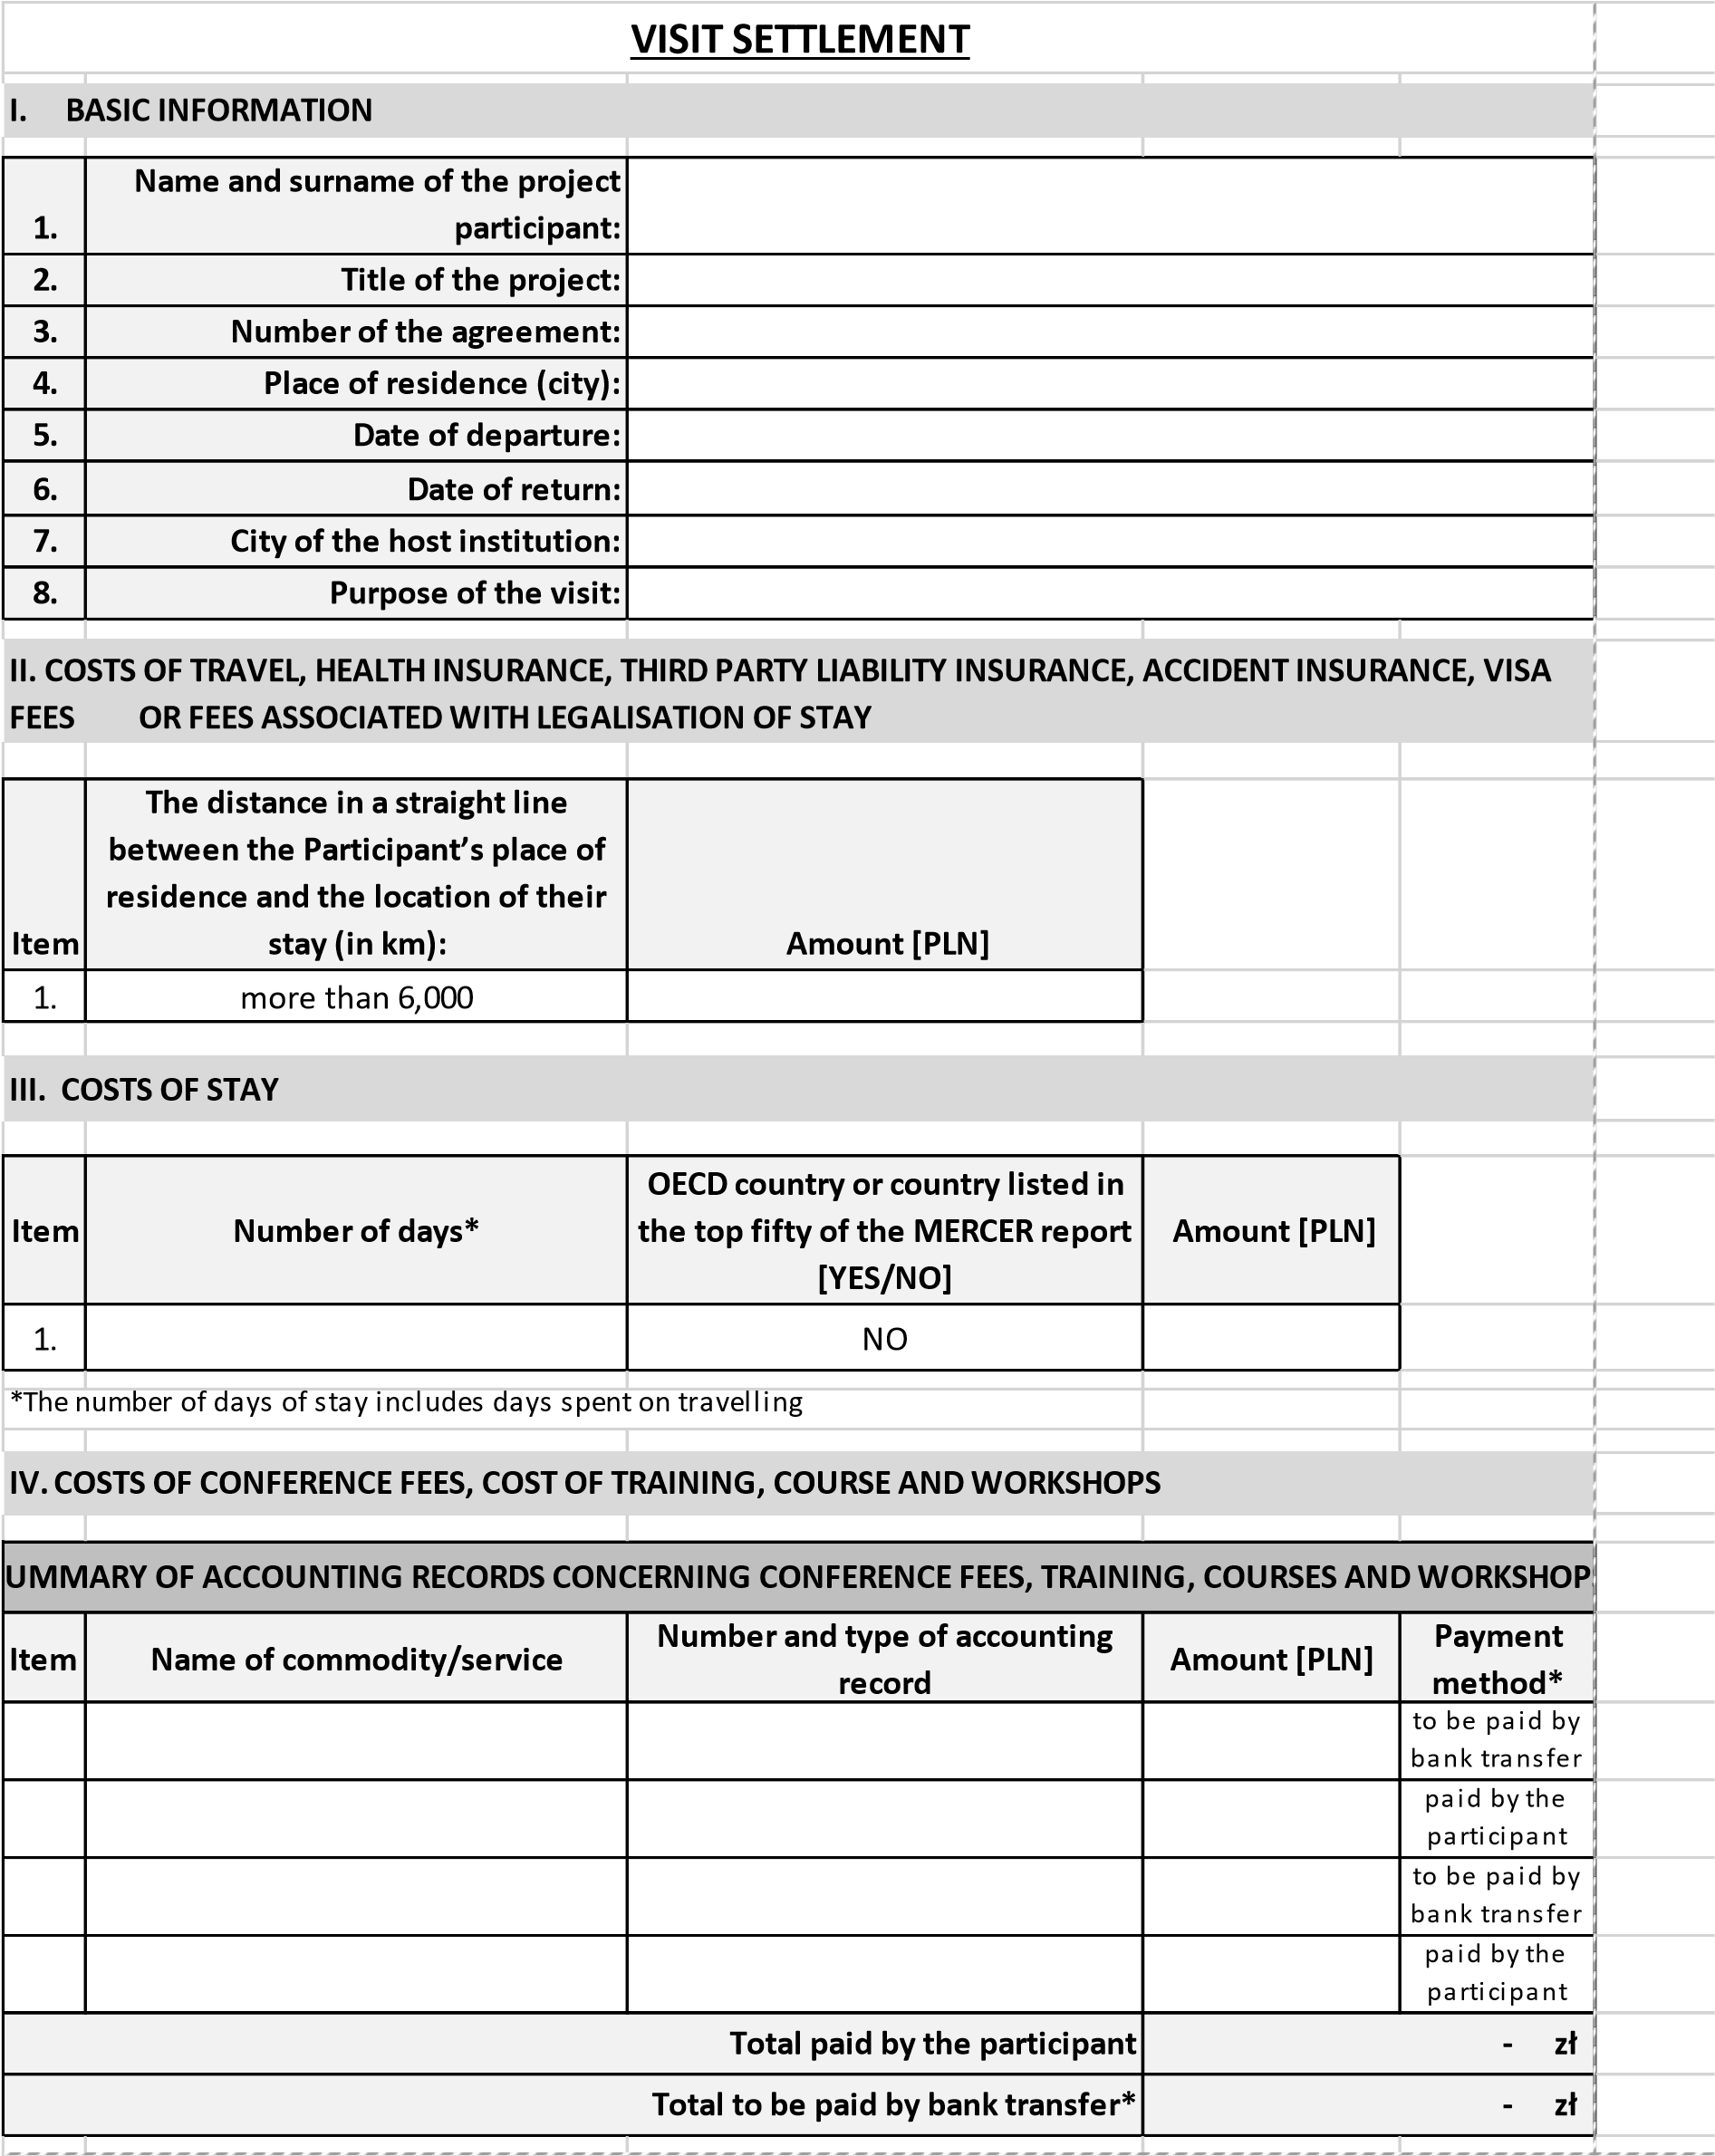

Original accounting records shown in the table constitute attachments to the visit settlement.
*All accounting records “to be paid by bank transfer” must be issued to the Beneficiary in the project
V. SETTLEMENT
1. Advance payment paid to the project participant |  |  | - zł
2. Costs due, including: [a + b + c] |  |  | - zł
a. | Costs of travel, health insurance, third party liability insurance, accident insurance, visa fees or fees associated with legalisation of stay |  | - zł
b. | Costs of stay |  | - zł
c. | Costs of conference fees, cost of training, courses and workshops paid by the participant |  | - zł
3. Amount to be reimbursed/paid [1–2] |  |  | - zł
4. Outstanding costs of conference fees, cost of training, courses and workshops |  |  | - zł
Please return/I undertake to return* the amount - zł resulting from the settlement of my visit.
* Delete as applicable
……………………………………………………… …………………………………………………….
Date and signature of the participant |  | Date and signature of the person approving the settlement

Attachment No 2 to the agreement between the Beneficiary and the Project Participant – Evaluation questionnaire

NOTE!
The presented survey questionnaire is for demonstration purposes only; the evaluation survey will be completed by the project participant online, NAWA will provide each project participant with the online survey form while the Beneficiary will only be informed about the fact that the survey has been completed.

Evaluation questionnaire
For the participants in the projects carried out under the
PROM PROGRAMME – INTERNATIONAL SCHOLARSHIP EXCHANGE OF DOCTORAL STUDENTS
AND ACADEMIC STAFF
of the Polish National Agency For Academic Exchange
Projects selected during the call for proposals in 2019:

Ladies and gentlemen, participants in the projects carried out under the PROM Programme,
This short evaluation survey is mandatory for all those who participated in the exchange under the PROM Programme – International scholarship exchange of doctoral students and academic staff. The main recipient of the information provided in this survey is NAWA. The questionnaire aims at understanding the effects of the PROM Programme and at making subsequent editions more efficient and useful for the recipients.

The Agency allows for the possibility of providing third parties with data collected through this questionnaire only in the form of aggregated statements with the guarantee of anonymity for each respondent. The only unanonymised information to be provided to the Institution, will be information about the fact that you have completed the survey; after all, this fact is a prerequisite for settling your exchange.

Thank you for your time and effort spent on completing the survey!

- The name of the HEI or scientific unit that granted and provided you with the funds for participating in the exchange (Institution)
……………………………………………………………………………………………………………………………………………….

- Please indicate your status at the HEI (at the scientific unit):

Doctoral student
Academic staff member
- Please specify the direction of your exchange:

departure from Poland
arrival to Poland

- What country was the destination of your visit?
Please select from the drop-down list:
- Please indicate the nature of your exchange:
Types of exchanges carried out under the PROM Programme
Active participation in a conference held abroad (including, for example, participation in a poster session and flash talk)
acquisition of materials for a doctoral thesis/scientific article
participation in the summer school/winter school (both as a student and as a lecturer)
carrying out measurements using unique apparatus, including using large research infrastructure not available (difficult to access) in Poland
participation in short forms of education, i.e. courses, workshops, professional or industrial internships and study visits, including at the premises of entrepreneurs
participation in training courses (including training courses on enterprise or implementation activity)
make archival/library research
participation in brokerage meetings
teaching classes
participation in preparing an international grant application
other, what kind?
………………………………………………………………………………………………

- Are you happy with your stay abroad under the Programme?

definitely not | rather not | difficult to say | rather yes | definitely yes

- How do you assess the usefulness of your exchange to your further career?

considering my further professional career, I assess my stay abroad as:
moderately useful | useful | very useful | difficult to say

- During your exchange, did you talk to people from other HEIs or scientific units about an opportunity to engage in scientific or teaching cooperation in the coming year?
No, I did not engage in such talks
Yes, I engaged in such talks, but I think that the actual establishment of cooperation in the coming year is unlikely or moderately likely
Yes, I engaged in such talks and I assume that it is highly likely that we will establish this cooperation in the coming year

- During their exchanges, participants in the Programme were provided opportunities to raise various types of competences, inter alia, scientific, professional, self-organisation, interpersonal and linguistic. Please assess whether during your exchange you raised the following types of competences.

a) Scientific competences:

- knowledge in specific field/fields of science
no | rather not | yes, to some extent | yes, definitely

- ability to apply knowledge to scientific work (e.g. operating equipment/apparatus)
no | rather not | yes, to some extent | yes, definitely

- ability to implement scientific research in developing commercial products or services
no | rather not | yes, to some extent | yes, definitely

- other (what kind)
……………………………………………………………………………………………………………………………………………………..
b) Professional competences (including teaching competence)

- acquisition of knowledge related to work performed (industry and specialist knowledge or knowledge of work management and organisation, teaching work methodology)

no | rather not | yes, to some extent | yes, definitely

- ability to apply solutions used at the host institution (e.g. on process management, work organisation, teaching classes)
no | rather not | yes, to some extent | yes, definitely

- other (what kind)
……………………………………………………………………………………………………………………………………………………..
c) Self-organisation competences
− ability to organise own work
no | rather not | yes, to some extent | yes, definitely

- ability to search and process information
no | rather not | yes, to some extent | yes, definitely

- other (what kind)
……………………………………………………………………………………………………………………………………………………..
d) Interpersonal competences

− | ability to establish/maintain cooperation with foreign partners
 | no | rather not | yes, to some extent | yes, definitely
− | ability to work in an international team
 | no | rather not | yes, to some extent | yes, definitely
− | ability to manage an international team
 | no | rather not | yes, to some extent | yes, definitely

- other (what kind)
…………………………………………………………………………………………………………………………………………………….. e) Linguistic competences

− ability to communicate in a foreign language
no | rather not | yes, to some extent | yes, definitely
− knowledge of specialist vocabulary
no | rather not | yes, to some extent | yes, definitely

- other (what kind)
……………………………………………………………………………………………………………………………………………………..
10. How do you assess the financial conditions offered to you during your exchange?
- I asses the coverage of travel expenses offered to me as:
fully satisfying
not fully satisfying
definitely unsatisfying

Justification
……………………………………………………………………………………………………………………………………………………………
……………………………………………………………………………………………………………………………………………………………

- The amount of living allowance offered to me was:
fully satisfying
not fully satisfying
definitely unsatisfying

Justification
……………………………………………………………………………………………………………………………………………………………
……………………………………………………………………………………………………………………………………………………………

- Would you recommend participation in the Programme to your colleagues from your HEI or scientific unit:
Yes
No

- Within a period between obtaining your degree of Master/ Engineer and participating in the exchange described here, have you participated in any other short-term exchanges? (exchanges lasting between 5 and 30 days, whose nature falls within the catalogue of actions described in the question 5 above).
Please indicate the number of exchanges; if there were no exchanges, please enter: „0”
Number of exchanges:

- Your other comments on the exchange or on the PROM Programme you would like to share with NAWA
……………………………………………………………………………………………………………………………………………………………
……………………………………………………………………………………………………………………………………………………………

Attachment No 3 to the agreement between the Beneficiary and the Project Participant – Model of the certificate

CERTIFICATE

Mrs/Mr

First name and surname

participated in

title of the event

during (from ........ to ......) in ......................... (venue of the event)

……………………………………………………. date and signature of the organiser

Description of the learning outcomes:

Please describe the learning outcomes as a result of participating in the event using the following formula and catalogue of concepts. The defined learning outcomes should be easy to verify. It is therefore necessary to avoid too general and too complex expressions, the language of the description should be simple and precise.

Knowledge (knows and understands...)

e.g.

The scholarship holder knows / searches for / formulates / explains / recognises / distinguishes / names / selects / translates / indicates......

Skills (can...)

The scholarship holder analyses/selects/uses/links/operates/ develops/organises/undertakes/calculates/carries out/prepares/ solves/implements/verifies/searches for/designs.....

Social competence (is ready to...)

The scholarship holder is eager to... /aware of... /able to... / oriented towards... /open to... /responsible for... /cares about... /proceeds according to... /strives for…
Attachment No 4 to the agreement between the Beneficiary and the Project Participant – Declaration concerning per-
sonal data

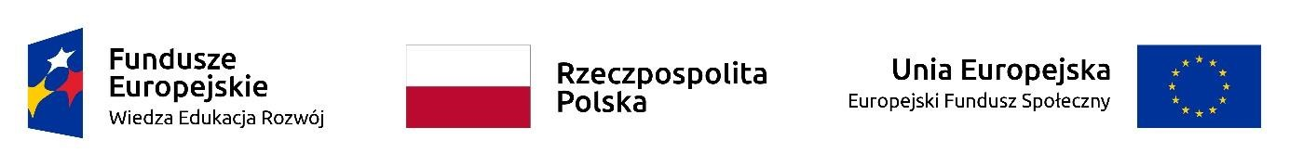

DECLARATION OF THE PROJECT PARTICIPANT
(information obligation implemented in relation to Articles 13 and 14 of the Regulation of the European Parliament and of the Council (EU) 2016/679)
In connection with joining the project entitled ........................................................................, I acknowledge that:
- The controller of my personal data is the minister competent for regional development acting as the Managing Authority for Knowledge, Education, Development Operational Programme 20142020, having its headquarters at ul. Wspólna 2/4, 00-926 Warsaw.
- The processing of my personal data is legal and fulfils the conditions referred to in Article 6(1)(c) and Article 9(2)(g) Regulation (EU) 2016/679 of the European Parliament and of the Council – the personal data are necessary for the implementation of the Knowledge, Education, Development Operational Programme 2014-2020 (OP KED) on the basis of:
  - with reference to the set “Knowledge-Education-Development Operational Programme”:
    - Regulation (EU) No 1303/2013 of the European Parliament and of the Council of
      - December 2013 establishing common rules on the European Regional Development Fund, the European Social Fund, the Cohesion Fund, the European Agricultural Fund for Rural Development and the European Maritime and Fisheries Fund and laying down general provisions on the European Regional Development Fund, the European Social Fund, the Cohesion Fund and the European Maritime and Fisheries Fund as well as repealing Council Regulation (EC) No. 1083/2006 (Official Journal EU L 347 of 20 December
2013, p. 320, as amended),
    - Regulation (EC) No 1304/2013 of the European Parliament and of the Council of
      - December 2013 on the European Social Fund and repealing Regulation (EC) No
1081/2006 (Official Journal of the EU L 347 of 20 December 2013, p. 470, as amended),
    - the Act of 11 July 2014 on principles of implementation of programmes in the area of cohesion policy financed in 2014–2020 financial perspective (Dz. [Journal of Laws] U. of 2017, item 1460, as amended);
  - with reference to the set “Central IT system supporting the implementation of operational programmes”:
    - Regulation (EU) No 1303/2013 of the European Parliament and of the Council of
      - December 2013 establishing common rules on the European Regional Development Fund, the European Social Fund, the Cohesion Fund, the European Agricultural Fund for Rural Development and the European Maritime and Fisheries Fund and establishing general provisions on the European Regional Development Fund, the European Social Fund, the Cohesion Fund and the European Maritime and Fisheries Fund as well as repealing Council Regulation (EC) No 1083/2006,
    - Regulation (EC) No 1304/2013 of the European Parliament and of the Council of
      - December 2013 on the European Social Fund and repealing Regulation (EC) No 1081/2006
    - the Act of 11 July 2014 on principles of implementation of programmes in the area of cohesion policy financed in 2014–2020 financial perspective (Dz. U. of 2017, item 1460, as amended);
    - Commission Implementing Regulation (EU) No 1011/2014 of 22 September 2014 establishing detailed rules for the implementation of Regulation (EU) No 1303/2013 of the European Parliament and of the Council with reference to the templates for the transmission of certain information to the Commission and detailed rules for the exchange of information between the beneficiaries and managing, certifying, audit and intermediary institutions (Official Journal of the EU L 286 of 30 September 2014, p. 1).
- My personal data will be processed solely for the purpose of project implementation......................................................................., in particular confirmation of eligibility of expenditure, provision of support, monitoring, evaluation, control, audit and reporting as well as information and promotion activities under OP KED.
- My personal data has been entrusted to the Intermediate Authority
  - .................................................................. (name and address of the competent Intermediate
Body), to the beneficiary implementing the project
  - ................................................................................................ (name and address of the beneficiary) and entities which, at the request of the beneficiary, participate in the implementation of the project
– ............... .....................................................................................................................................
(name and address of the above-mentioned entities). My personal data may be transferred to entities implementing evaluation studies commissioned by the Managing Authority, Intermediate Body or Beneficiary. My personal data may also be entrusted to specialist companies implementing, at the request of the Managing Authority, the Intermediate Body and the beneficiary, inspections and audits under OP KED.
- Providing data is a prerequisite for receiving support, and refusal to provide it is tantamount to inability of providing support under the project.
- Within 4 weeks after completing participation in the project, I will provide the beneficiary with data regarding my status on the labour market and information on participation in education or training and obtaining qualifications or acquisition of competences.
- Within three months after completing participation in the project, I will provide data on my status on the labour market.
- In order to confirm the eligibility of expenditure in the project, my personal data such as first name (names), surname, PESEL number, project number, project start date, project end date, insurance title code, premium for health insurance, premium amount accident insurance can be processed in the set “Social Insurance Institution personal data set”, which is administered by the minister competent for regional development. The processing of my personal data is legal and fulfils the conditions referred to in Article 6(1)(c) and Article 9(2)(g) Regulation (EU) 2016/679 of the European Parliament and of the Council – the personal data are necessary for the implementation of the Knowledge, Education, Development Operational Programme 2014-2020 (OP KED) on the basis of:
  - Regulation (EU) No 1303/2013 of the European Parliament and of the Council of
17 December 2013 establishing common rules on the European Regional Development Fund,
the European Social Fund, the Cohesion Fund, the European Agricultural Fund for Rural Development and the European Maritime and Fisheries Fund and establishing general provisions on the European Regional Development Fund, the European Social Fund, the Cohesion Fund and the European Maritime and Fisheries Fund as well as repealing Council Regulation (EC) No 1083/2006,
  - Regulation (EC) No 1304/2013 of the European Parliament and of the Council of 17 December 2013 on the European Social Fund and repealing Regulation (EC) No 1081/2006
  - the Act of 11 July 2014 on principles of implementation of programmes in the area of cohesion policy financed in 2014–2020 financial perspective (Dz. U. of 2017, item 1460, as amended); 4) Act of 13 October 1998 on social insurance system (Dz. U. of 2017, item 1778, as amended).
My personal data has been entrusted to the Intermediate Authority
  - .................................................................. (name and address of the competent Intermediate
Body), to the beneficiary implementing the project
  - ................................................................................................ (name and address of the benefi-
ciary) and entities which, at the request of the beneficiary, participate in the implementation of the project
– ............... .....................................................................................................................................
(name and address of the above-mentioned entities). My personal data may be transferred to entities implementing evaluation studies commissioned by the Managing Authority, Intermediate Body or Beneficiary. My personal data may also be entrusted to specialist companies implementing, at the request of the Managing Authority, the Intermediate Body and the beneficiary, inspections and audits under OP KED.
- My personal data will not be transferred to a third country or an international organisation.
- My personal data will not be subjected to automated decision making.
- My personal data will be stored until the Knowledge-Education-Development Operational Programme 2014–2020 is settled and the process of archiving documentation is completed.
- I can contact the Data Protection Inspector by sending a message to the following e-mail address: iod@miir.gov.pl or the e-mail address ........................................................ (when applicable - please provide the contact details of the data protection officer to the Beneficiary).
- I have the right to lodge a complaint with the supervisory body, which is the President of the Office for Personal Data Protection.
- I have the right to access my data and correct, delete or otherwise limit its processing.

…..……………………………………… | ……………………………………………
PLACE AND DATE | LEGIBLE SIGNATURE OF THE PROJECT PARTICIPANT*
* In the case of a minor’s declaration of participation, the declaration should be signed by their legal guardian.

The learning outcome is what the learner knows, understands and can do as a result of learning, expressed in terms of knowledge, skills and social competence.
Knowledge – a collection of descriptions of objects and facts, principles, theories and practices acquired in the learning process and relating to the field of learning or professional activity.
Skills – the ability, assimilated in the learning process, to perform tasks and solve problems specific to the field of learning or professional activity.
Social competence – the ability to participate autonomously and responsibly in the professional and social life and to shape own development, taking into account the ethical context of own behaviour.
Processing of personal data as part of the Collection of personal data from the Polish Social Insurance Institution (ZUS) relates to a situation where the project grant agreement has been concluded with the Beneficiary by the Ministry of Family, Labour and Social Policy or Voivodeship Labour office.

